**LAB ASSIGNMENT-3**

LAKSHMI BHARGAVI KADALI

16158203

1. **Extended Mobile Web Client Application**

* This is the extended web application for my lab-2 assignment. This actually includes two different options for the user a) To get the Geo Location Services and b) To enable Local Storage Services to the users.

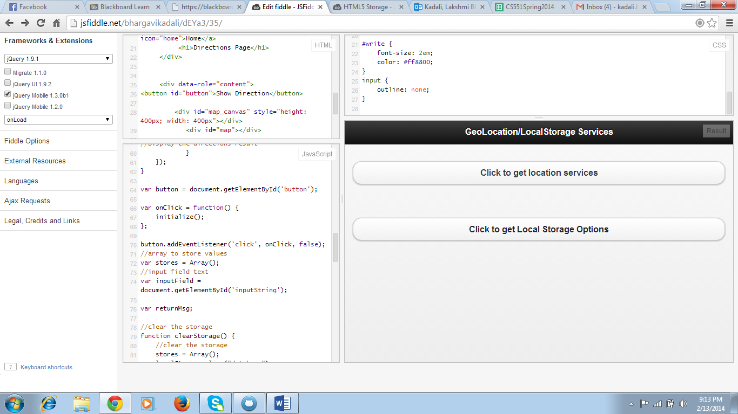

* On clicking the first option ie. Click to get location services, the user will be displayed with the following page.

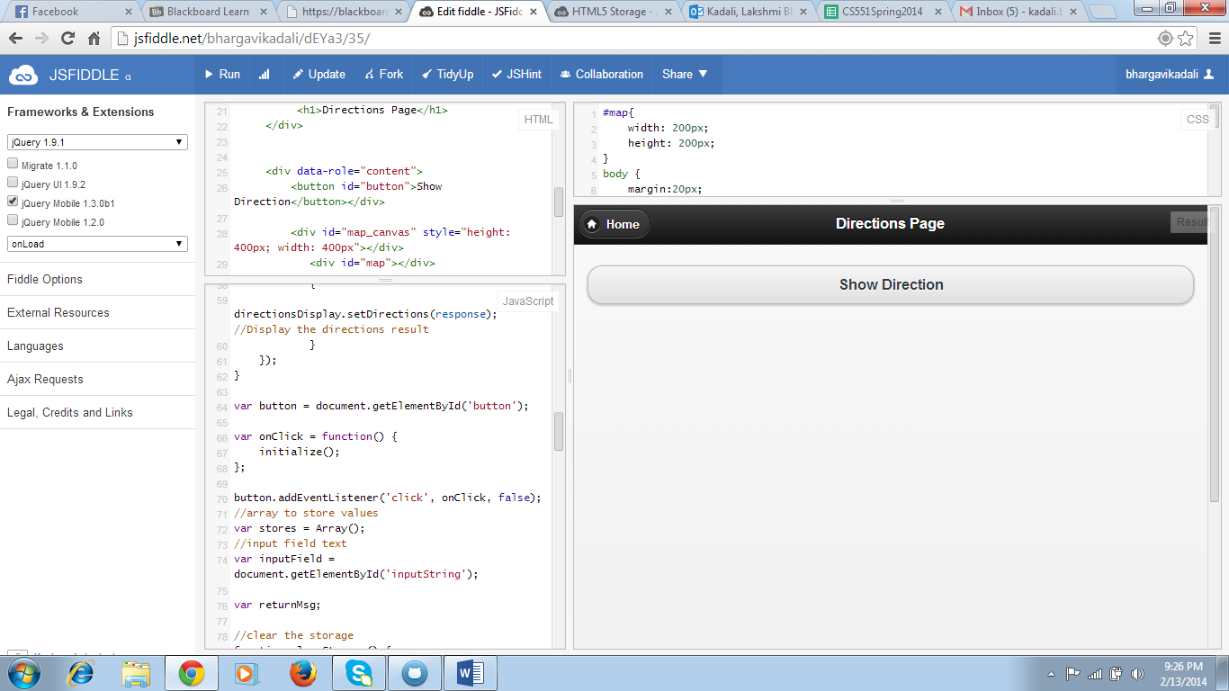

* Now on entering the button “Show Directions”, directions from the source to the destination location will be displayed.

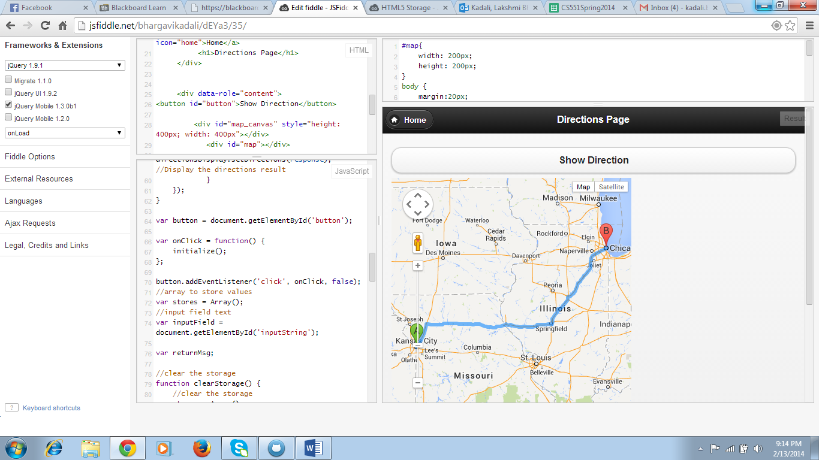

* Now, by clicking the home button on top of the page, the user will be back to the Home page.



* By clicking on “Click to get Local Storage Options”, the user will be navigated to the following page.

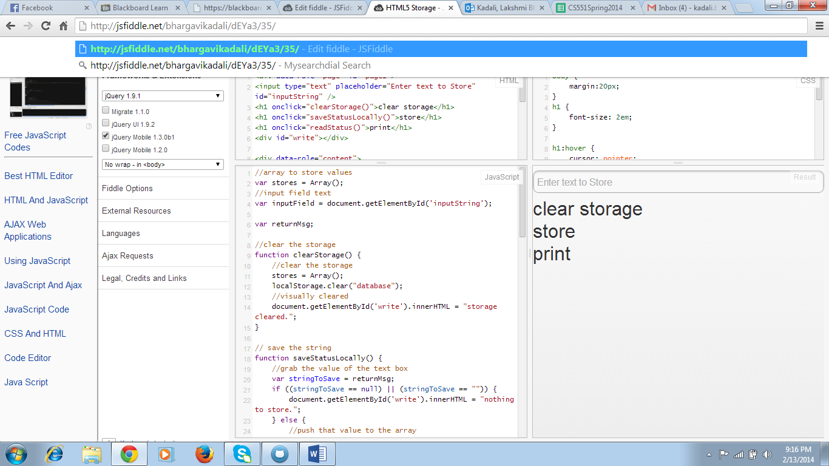

* This is the page that will be displayed when the user clicks local storage button. And in that, on clicking clear storage button the following message will be displayed.

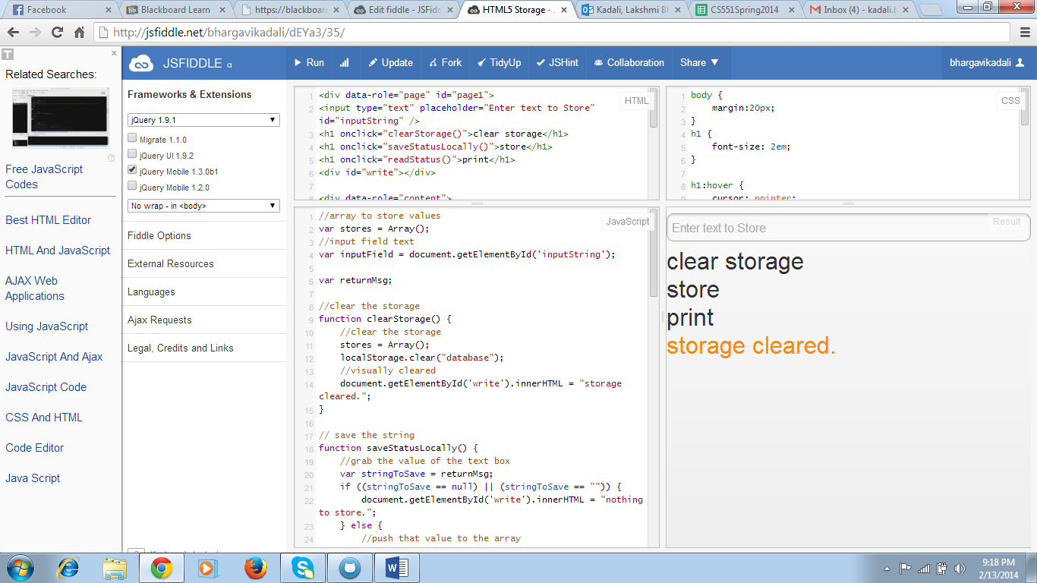

* Then by entering the required data and then clicking store button, the following message will be displayed.

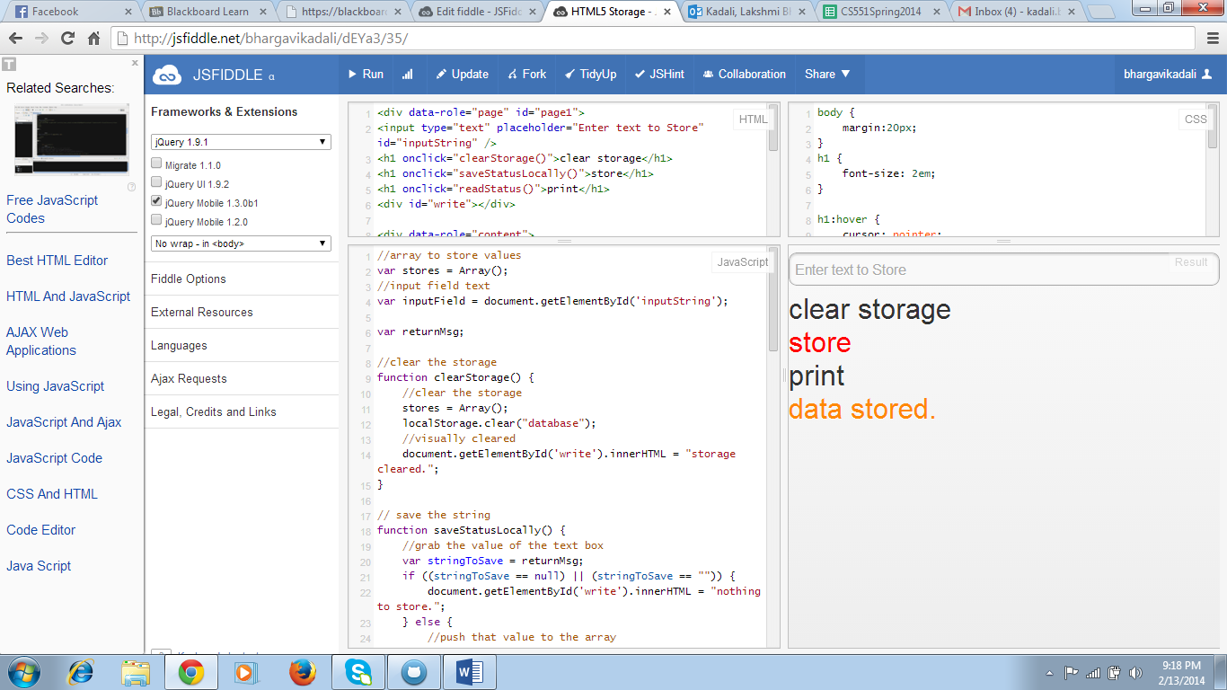

* Now, by clicking print option, the weather details of kansas city will be displayed to the customer.

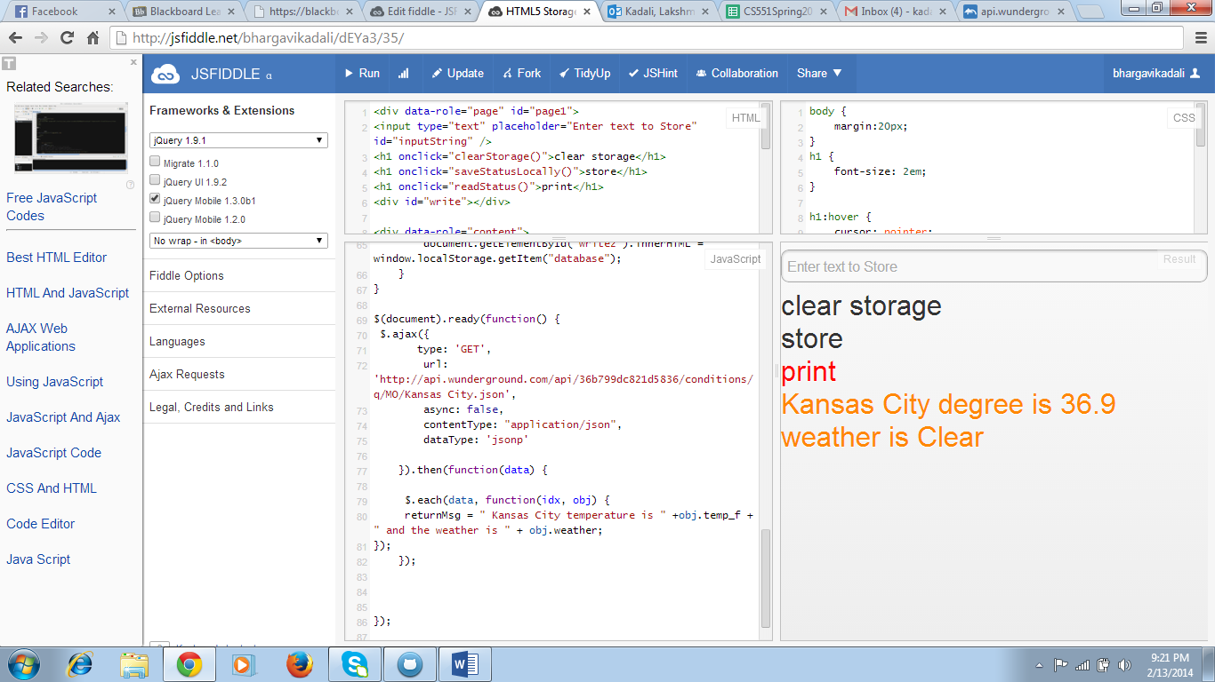

1. **Mashup application**

* This is my first application included in mashup which shows the users current location.

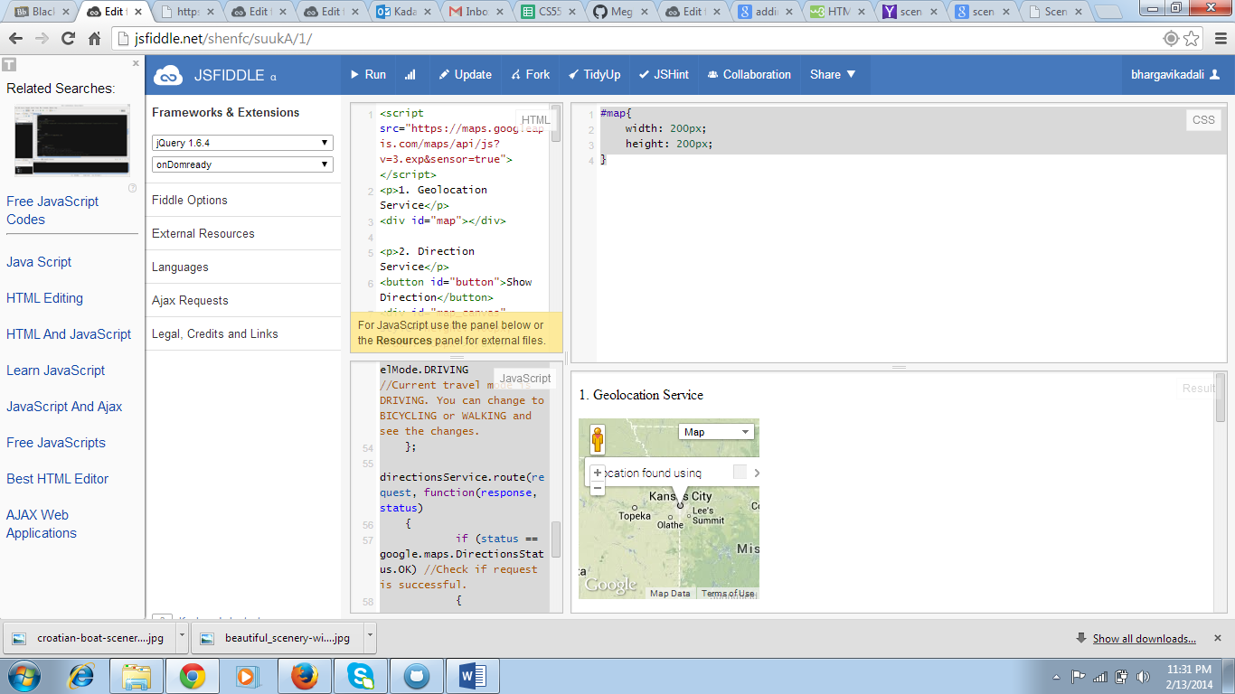

* This is the second application I have included in mash up which shows the directions from source to destination specified by the user.

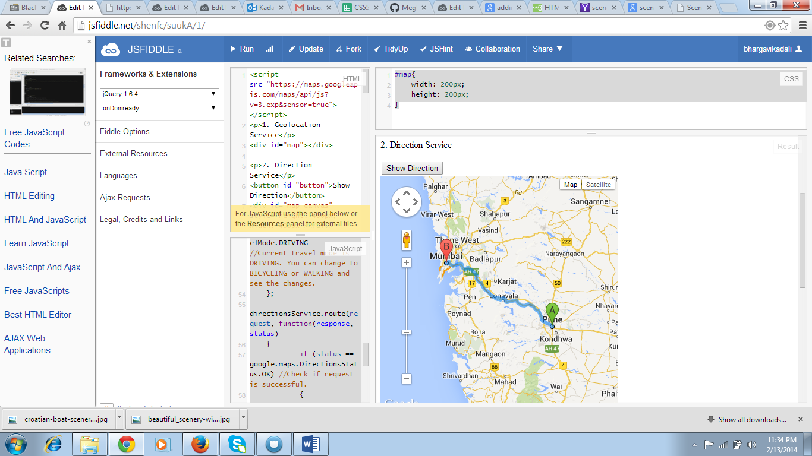

* This will show the third mash up application which tells the user to like our page on facebook. And this inturn leads to facebook login details.

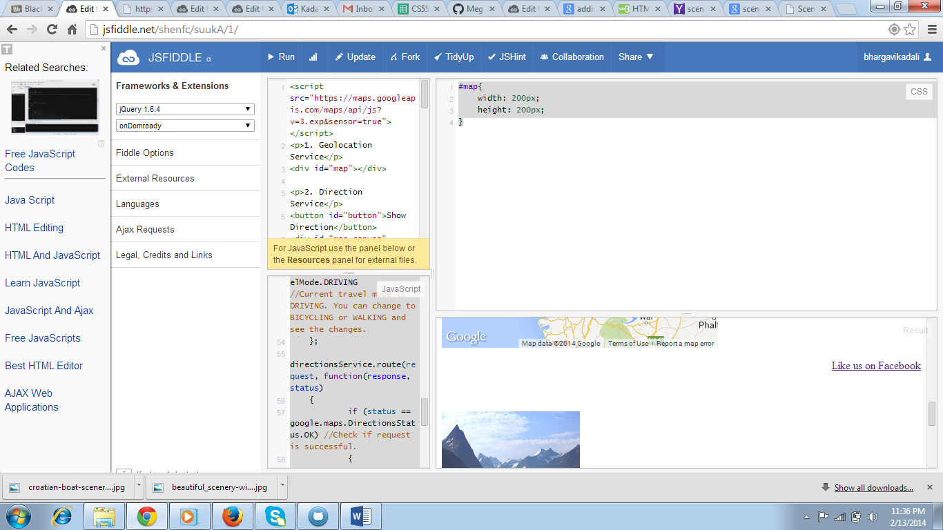

* And now, an image is being displayed in my mash up application.

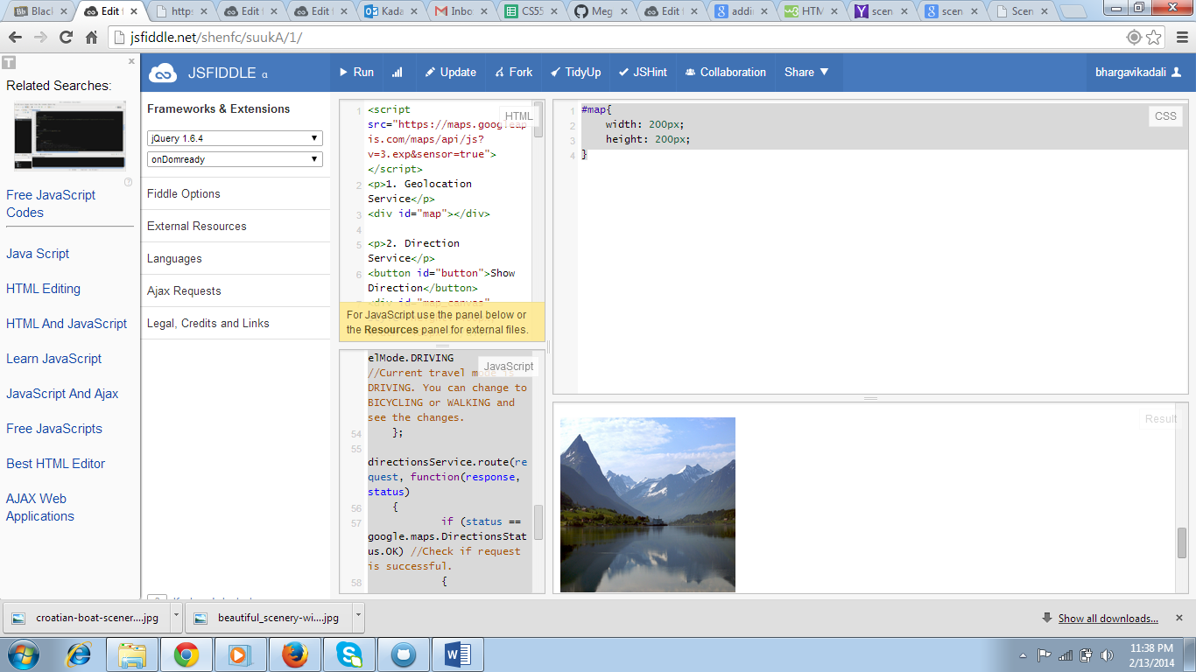

* Finally, I have included the twitter page links which helps the user to connect to my application.

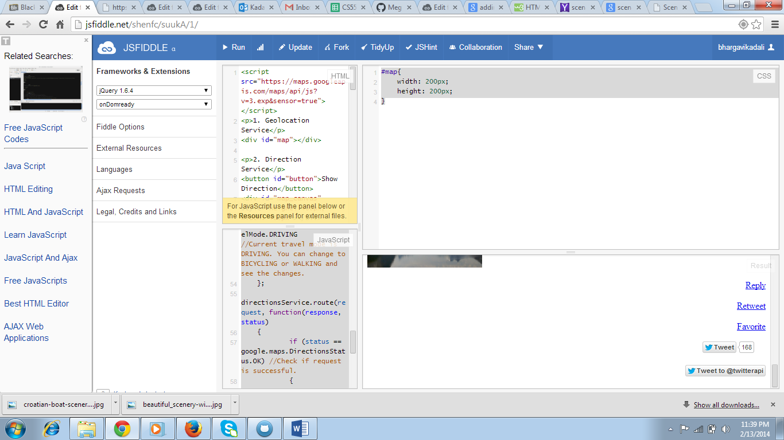

* This is the final scenario of my mash up application.

